Know International Rules of the Road and appropriate Rules of the Road for your area. Know rules for motor or sail vessels, including lighting, day shapes, right-of-way, maneuvering signals, and signals in restricted visibility.

Rules of the Road Summarized
By Chief Warrant Officer Jim Krzenski
Commanding Officer, U.S. Coast Guard Station Fort Pierce
Collisions between boats are one of the most dangerous and frequently occurring mishaps on our nations waters. In 1996, 5174 boat collisions occurred nationwide. These collisions not only resulted in vessel damage but often resulted in serious personal injury or death. Often the collision will result in people on board being thrown overboard by the force of the impact.
Avoiding collisions on the water differs in many ways from avoiding collisions while driving in your car. The one contributing factor which is similar between boats as compared to automobiles is SPEED. It has been statistically proven that the number of collisions between vehicles, be they of the marine or roadway type, are reduced as speed is reduced.
Although the newer high powered boats can reach speeds comparable to those of an automobile, there are no seat belts or brakes on most boats. Boats can either alter course or reverse their engines. Similar to the rules of the road used to prevent collisions on our nations highways, there are navigation rules which are used to prevent collisions on our nation’s and the world’s waterways.
The U.S. Coast Guard’s Navigation Rules (International-Inland) publication can be ordered by calling the U.S. Government Printing office at (202) 783-3238. (You can also view them here) The 36 rules and five annexes contained within this publication are specifically designed to help you prevent vessel collisions. All mariners are required to know and responsibly apply these navigation rules when operating their vessels. Some of the most important rules contained within this publication are summarized below.
Rule - 2, Responsibility, requires that due regard shall he given to all dangers of navigation and collision. This rule allows the mariner to depart from the rules as necessary to avoid the immediate danger of collision. This rule is often applied when the risk of collision between three or more vessels may occur. It is the mariner’s responsibility to take the necessary actions to avoid a collision.
Rule - 4 requires that every vessel shall at all times maintain a proper lookout using sight and hearing as well as by all available means appropriate in the prevailing circumstances so as to make a full appraisal of the situation and of the possible risk of collision.
Rule - 6 requires that every vessel shall at all times proceed at a safe speed so that she can take proper and effective action to avoid collision and be stopped within a distance appropriate to the prevailing circumstances and conditions. In determining safe speed the following factors shall be among those taken into account: the visibility, traffic density, maneuverability of the vessel with special reference to stopping distance and turning ability, at night the presence of background light such as from shore lights, the state of the wind, sea, current, proximity of navigational hazards, and the draft in relation to the available depth of water. Additionally, vessels with operational radar must use that radar to its fullest extent to determine the risk of collision.
Rule - 7 Risk of Collision, states that every vessel shall use all available means to determine if risk of collision exists; if there is any doubt, assume that it does exist. Risk of collision shall be deemed to exist if the compass bearing from your vessel to an approaching vessel does not change. Constant bearing decreasing range (CBDR) is the term we use to describe this situation. Collision risk may sometimes exist even when appreciable bearing change is evident, particularly when approaching a very large vessel or a vessel towing or when approaching a vessel at very close ranges
Rule 8, Action to Avoid Collision, provides specific guidance on how to maneuver your vessel so as to avoid a collision. Changes in course and speed shall be large enough so as to be readily apparent to the other vessel. If there is sufficient sea room, alteration of course alone may be the most effective action to avoid a close quarters situation provided that it is made in good time, is substantial and does not result in another close quarters situation. If necessary to avoid collision or allow more time to assess the situation, a vessel shall slacken her speed or take all way off by stopping or reversing her propulsion. A vessel which is required not to impede the passage of another vessel shall take early and substantial action to allow sufficient sea room for the passage of the other vessel.
Rule 9, Narrow Channels, states that a vessel proceeding along the course of a narrow channel or fairway shall keep as near to the outer limit of the channel which lies on her starboard (right) side as is safe and practicable, A vessel less than 20 meters in length or sailing vessel shall not impede the passage of a vessel, which can safely navigate only within the narrow channel.
Rule 14, Head-On Situation, states that vessels which are approaching head-on shall alter course to starboard so each will pass port to port.
Rule 15, Crossing Situation, states that when two power driven vessels are crossing so as to involve risk of collision, the vessel which has the other vessel on her starboard side shall keep out of the way, and shall, if the circumstances of the case admit, avoid crossing ahead of the other vessel.
Mariners should not limit their knowledge of the rules to this article. In addition to the rules I have summarized, there are other rules which apply to vessels operating in restricted visibility, rules which prescribe the types of navigation lights and sound signals required by vessels. It is vital that all boat operators become students of the navigation rules and help prevent collisions. I strongly encourage all boaters to complete either the U.S. Power Squadron or U.S. Coast Guard Auxiliary Boating Skills and Seamanship Course. To find out the time and date of the next Coast Guard Auxiliary course offered near you, please call the Coast Guard’s customer service number at 1-800-368-5647. May all your boating be safe!!!!

More Rules of the Road
There are two sets of navigation rules; inland and international. A nautical chart will show you the demarcation lines where the rules change from international to inland and vice versa. In general, these demarcation lines follow the coastline and cross inlets and bays. On the seaward side of the demarcation lines international rules apply. We will concentrate on the inland rules, since most of your recreational boating will occur on the landward side of the demarcation lines.
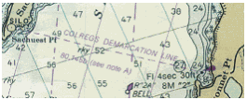
The Nav Rules are written with the understanding that not all boats can maneuver with the same ease. Therefore, Rule 18 states that certain vessels must keep out of the way of other vessels due to their ability to maneuver.
A power driven vessel underway must keep out of the way of the following:
  - A sailing vessel, under sail only, and vessels propelled by oars or paddles. (Note: when a sailboat has its motor running, it is considered a power driven vessel).
  - A vessel engaged in fishing, whose fishing equipment restricts its maneuverability. This does not include a sport fisher or party boat and generally means a commercial fishing vessel.
  - A vessel with restricted maneuverability such as a dredge or tow boat, a boat engaged in work that restricts it to a certain area, or a vessel transferring supplies to another vessel.
  - A vessel not under command – broken down.
Each of these vessels must keep out of the way of the next vessel in the hierarchy. For example, a sailboat must keep out of the way of a vessel engaged in fishing, which in turn must keep out of the way of a vessel with restricted maneuverability. And everyone must keep out of the way of a vessel not under command.
When two power driven vessels are in sight of one another and the possibility of collision exists, one vessel is designated by the rules as the stand-on vessel and the other is designated as the give-way vessel. The stand-on vessel should maintain its course and speed. The give-way vessel must take early and substantial action to avoid collision. If it becomes apparent that the actions taken (or not taken) by the give-way vessel are dangerous or insufficient, the stand-on vessel must act to avoid collision.
Meeting Situations
In the following situations, the give-way vessel must take action to keep well clear. The stand-on vessel should maintain its course and speed. If it becomes apparent that the actions taken (or not taken) by the give-way vessel are dangerous or insufficient, you should take action to avoid collision.
Meeting Head-On
When two power driven vessels are approaching head-on or nearly so, either vessel shall indicate its intent which the other vessel shall answer promptly. In a meeting situation neither vessel is the stand-on vessel.
It is generally accepted that you should alter course to starboard and pass port-to-port. The accompanying sound signal is one short blast. If you cannot pass port-to-port due to an obstruction or other vessels, you should sound two short blasts to indicate your intention to pass starboard-to-starboard. Make sure the other vessel understands your intent before proceeding. The other vessel should return your two-short-blast signal.
Passing Port to Port

Passing Starboard to Starboard
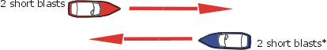
Meeting Head to Head
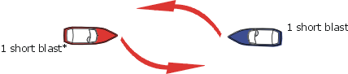
* Response not sounded on International Waters
Overtaking
When two vessels are moving in the same direction, and the astern vessel wishes to pass, it must initiate the signal to pass as shown in the diagram. The vessel passing is the give-way vessel and should keep out of the way of the vessel being passed. The vessel being passed is the stand-on vessel and must maintain its course and speed. If the stand-on vessel realizes that the course intended by the give-way vessel is not safe, it should sound the danger or doubt signal.
A vessel is deemed to be overtaking when the vessel is approaching the vessel ahead in a direction of 22.5 degrees abaft her beam. At night you would only be able to see the stern light of the vessel being overtaken. You would not be able to see either sidelight.

Inland Rules  "I intend to pass you on your port side"  2 short blasts (1 sec.)  "Agreement"  2 short blasts (1 sec.)  International Rules:  "I intend to pass you on your port side"  2 prolonged blasts/2 short  "Agreement"  1 prolonged/1 short/1 prolonged/1 short | 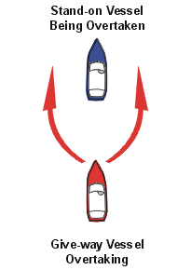 | Inland Rules  "I intend to pass you on your starboard side"  1 short blast (1 sec.)  "Agreement"  1 short blast (1 sec.)  International Rules:  "I intend to pass you on your starboard side"  2 prolonged blasts/1 short  "Agreement"  1 prolonged/1 short/1 prolonged/1 short
If you are the overtaking vessel, remember that you are the give-way vessel until well past, and safely clear of, the passed vessel. Do not cut in front, impede or endanger another vessel.
Crossing
When two power driven vessels are approaching at right angles or nearly so, and risk of collision exists, the vessel on the right is the stand-on vessel and must hold its course and speed. The other vessel, the give-way vessel, shall maneuver to keep clear of the stand-on vessel and shall pass it by its stern. If necessary, slow or stop or reverse until the stand-on vessel is clear.
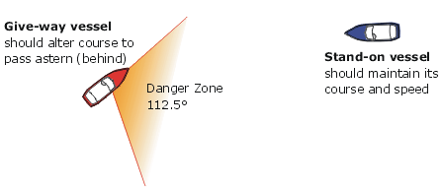
In the example above, the red vessel is the give-way vessel and should alter course and speed to pass behind the blue vessel. If the skipper of the blue vessel does not observe the red vessel taking action to avoid collision, then he/she must take the required action to avoid a collision.
Sailing Craft and vessels propelled by oars or paddles
Sailing craft (not under power) and boats propelled by oars or paddles are stand-on vessels when approaching power driven vessels. In this situation, the power-driven vessel should alter course to pass behind the sailing vessel.
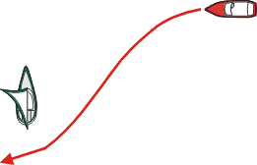

An exception to this is if the sailing craft or self-propelled vessel is passing a power driven vessel. In an overtaking situation, the overtaking vessel is the give-way vessel, even if it is not propelled by an engine.
Sailing vessels have special situations when meeting and crossing each other. These are described in Chapter 9, Section 5, Sailing.
Navigating Narrow Channels
The rules tell you to stay to the starboard side of narrow channels. Make sure that you do not impede a vessel that is constrained by draft, i.e. a large vessel that must operate within the channel in order to make way safely. When crossing a channel, do so at a right angle and in such a way as to avoid causing the traffic in the channel to make course or speed changes. Do not anchor in a channel unless you cannot make way (broken down, etc.).
When operating on the Great Lakes, Western Rivers and other designated rivers, the downbound vessel (going with the current) has the right of way over a vessel going upstream. This is because a vessel going upstream can maneuver better than a vessel going downstream.
If you approach a bend in a river around which you cannot see, sound one prolonged blast to alert vessels approaching from the other side of the bend that you are there. If another vessel is around the bend, it should answer with one prolonged blast. Conversely, if you hear a prolonged blast as you approach the bend, answer with a prolonged blast.

Commercial Vessel Situations

If at all possible stay out of areas where there is commercial vessel traffic such as shipping lanes or traffic separation zones. Large ships and barges have special problems in maneuvering and cannot and will not get out of your way.
If you must operate around commercial vessels take heed of the following:
- Avoid ship channels. If you must cross do so at right angles and as quickly as possible.
- Be alert. Watch for traffic.
- Be seen, especially at night.
- Know the sound signals, especially the danger or doubt signal.
- Keep your VHF radio tuned to channel 16 and listen carefully.
- Order all aboard to wear PFDs.
- Be familiar with the area and have current navigation charts.
- Don’t be a non-survivor of a collision with a large ship.

Restricted Visibility
When operating at night, or other times of restricted visibility, the required navigation lights as set forth in the required equipment section are mandatory to be displayed. The lights themselves will let each vessel know which is the stand-on or give-way vessel and each vessel should react accordingly.
A vessel approaching in your danger zone (approaching from your starboard side) will show its red (stop) port light. That vessel will see your green (go) starboard light. If you do not see a mast light, you know the vessel is not power driven (or not operating under its own power, as in the case of a boat being towed) and has the right of way over power driven vessels.
Navigation Lights  Power Driven Vessel  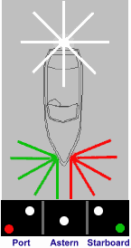 | Navigation Lights  Sailing Vessel  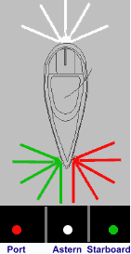
During nighttime operations vision can be tricky at best, so a proper lookout and safe speed need constant attention.
During times of restricted visibility such as smoke or fog, additional sound signals are required. Both inland and international rules require that any vessel underway in or near a restricted visibility area sound a warning signal every two minutes.
Motorboats must sound one prolonged blast every two minutes. Sailing vessels must sound one prolonged blast plus two short blasts every two minutes. When a power driven vessel is stopped (underway but making no way) she shall sound two prolonged blasts every two minutes. Vessels at anchor shall sound rapid strokes on the bell for 5 seconds at intervals not less than one minute (however, if your vessel is less than 65 feet and you are anchored in a designated "special anchorage" you do not need to sound these signals). Vessels aground shall sound three distinct strokes on the bell ("I Am Aground"), followed by five seconds rapid ringing of the bell, followed by three distinct strokes on the bell ("I Am Aground").
One Prolonged Blast One Short Blast
One Stroke on the Bell
Power Vessel Underway
Every Two Minutes
Sailing Vessel Underway
Every Two Minutes
Power Vessel Underway
but making no way
Vessel at Anchor  Every Minute | 5 seconds of rapid ringing
Vessel Aground  Every Minute | 3 strokes  5 seconds rapid ringing  3 strokes
Aids To Navigation
In order to find our way safely from place to place on the water we must depend on road signs just as we do on land. The aids to navigation are the road signs of the water. Learning to understand them requires experience and practice. However, the benefit to be derived in being able to navigate safely by using the system is well worth the effort.
There are two systems of marking the waterways in the United States; the U.S Aids to Navigation System (ATONS) which includes the Western River System, and the Uniform State Waterway Marking System. Both systems are described below. The Uniform State Waterway Marking System is being phased out in favor of the U.S. ATONS. This change will be gradual and should be complete by 2003. In the meantime, you may see either system in use on state waterways.
U.S. Aids to Navigation (U.S. ATONS)
The buoys and beacons in this system conform to the International Association of Lighthouse Authorities (IALA) guidelines and are located in IALA region B. They are sometimes referred to as the IALA-B system. In this system, there are lateral and non-lateral markers. The lateral markers indicate the navigable channel by their position, shape, coloring, numbering and light characteristics. The non-lateral markers are informational and regulatory markers.
To navigate safely using the lateral markers, you should pass between the red and green. Returning from sea, the red markers are on your right (red, right, returning) and the green are on your left.
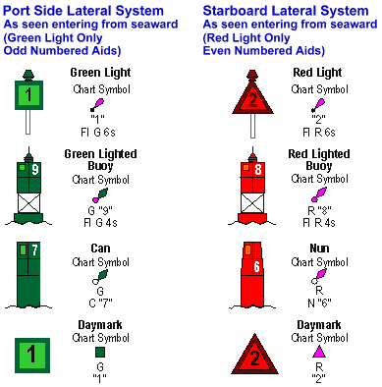
Lateral Buoys and waterway markers
In the International system, navigation aids mark the edges of channels to tell which way open water is. They are called day beacons if unlighted, lights if lighted at night, or buoys if they are floating. Some buoys are also lighted for identification at night.
"Red, Right, Returning" tells you to leave the red markers to your right, or starboard, when returning from sea. The green markers are then left on your port side and between is the channel. Be sure to look behind you when navigating a narrow channel to make sure you are not being pushed out by wind or current.
Floating Red markers are called nuns and are triangular in shape. They are numbered with even numbers. Floating Green markers, on the other hand, are called cans and are square or shaped like a large can and carry odd numbers.
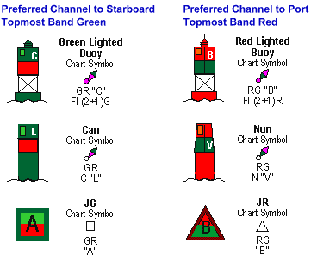
Preferred channel markers or junction markers indicate the preferred channel at points where the waterway splits or branches off in another direction. If you are returning from sea and see a preferred channel marker that is red over green, to stay in the main channel you would consider the marker as if it were a red marker and keep it on your right. However, if your intended destination is the waterway branch consider the marker a green marker and leave to your port side. (See example below.)
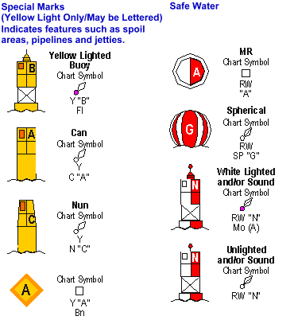

When looking at a chart you read the markers as follows:
 | The first marker you see entering from sea is the open, or safe water, marker. The RW "G" means that it is a Red and White striped marker with, in this case, the letter "G" on it.
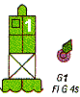 | A lighted marker flashes at night and during restricted visibility. The next marker you see as you enter this waterway is the G "1" Fl G 4 sec. This tells you it is Green, has the number 1 on it, and it Flashes Green once each 4 seconds.
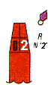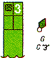 | R N "2" plus the red symbol indicates a Red Nun buoy with the even number 2 on it. Conversely G C "3", is a Green Can buoy with the odd number 3 on it.
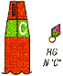 | When entering from seaward you may find two channels which separate and go in different directions. A junction marker referred to as RGN "C" uses its top color to show you the major or primary channel. This is represented by a Red and Green Nun buoy with (in this case) a "C" on it. You use the top color and shape as if it were a stand alone marker if you want to follow the primary channel. In this case leave the Red Nun to the right. Otherwise use the bottom color.
Intracoastal Waterway System
The Intracoastal Waterway (ICW) runs parallel to the Atlantic and Gulf Coasts from Manasquan Inlet on the New Jersey shore to Brownsville, Texas at the Mexican border. Aids to navigation marking these waterways have some portion of them marked with yellow. Otherwise, the colors and numbering of buoys and day marks, and lights follow the same system as that observed in all other waterways.
Red, right, returning also applies to the ICW markers. However, how do you know which way is returning? Generally south, from New Jersey to Brownsville, Texas is considered returning. So, going generally south on the ICW you would have red right. There are some areas of the ICW such as the West Coast of Florida where you are actually going north. Still, if you are going from New Jersey to Texas you are returning.
Aids to navigation marking the Intracoastal Waterway (ICW) display unique yellow symbols to distinguish them from aids marking other waters. Yellow triangles indicate aids should be passed by keeping them on the starboard side of the vessel. Yellow squares indicate aids should be passed by keeping them on the port side of the vessel. A yellow horizontal band has no lateral significance, but simply identifies aids as marking the ICW.
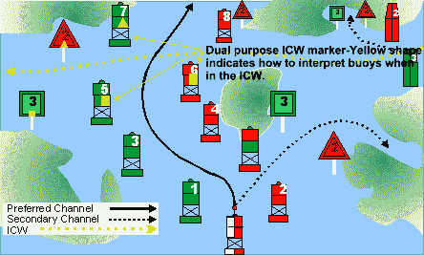
Dual Purpose Markings
Red Buoy with yellow square -- marks left side of channel when traveling the intracoastal waterway (south), but right side of channel when coming in from sea.
Green Buoy with yellow triangle -- marks right side of channel when traveling the intracoastal waterway (south), but left side of channel when coming in from sea.
Red Buoy with yellow triangle -- marks right side of channel when traveling the intracoastal waterway (south), and right side of channel when coming in from sea.
Green Buoy with yellow square -- marks left side of the channel when traveling the intracoastal waterway (south), and left side of channel when coming in from sea.
Non-Lateral Informational and Regulatory Markers
Regulatory or informational markers are used to advise you of situations, dangers, or directions. They may indicate shoals, swim areas, speed zones, etc. They can be easily identified by the orange bands on the top and bottom of each buoy.
  Boat Exclusion Area:  Explanation may be placed outside the crossed diamond shape, such as dam, rapids,  swim area, etc. |   Danger:  The nature of danger may be indicated inside the diamond shape, such as rock, wreck, shoal, dam, etc. |   Controlled Area:  Type of control is indicated in the circle, such as slow, no wake, anchoring, etc.
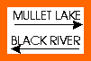  Information:  For displaying information  such as directions, distances, locations, etc. |   Buoy used to display  regulatory markers. |   May show white light  May be lettered
Other Non-Lateral Markers
Safe Water Marker: These are white with red vertical stripes and indicate unobstructed water on all sides. They mark mid-channels or fairways and may be passed on either side. | 
Inland Waters Obstruction Marker: These are white with black vertical stripes and indicate an obstruction to navigation. You should not pass between these buoys and the shore. | 
Mooring Buoys: These are white with a blue horizontal band. They are usually placed in marinas and other areas where vessels are allowed to anchor. These are the only buoys you may legally tie up to. | 
Western Waterway Marking System
Found only on the Mississippi River and its tributaries as defined by the U.S. Coast Guard in Rule 3 of the COLREGs. These aids to navigation are not numbered as in IALA-B system. Numbers indicate mileage from a fixed point. Lights on green aids show a single-flash which may be green or white. Lights on red aids show a group-flash which may be red or white. Diamond-shaped crossing dayboards, red or green as appropriate, are used to indicate where the river channel crosses one bank to the other.
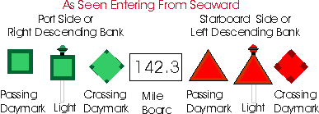
Uniform State Waterway Marking System (USWMS)
On bodies of water wholly within state boundaries and not navigable to the sea, each state is responsible for establishing and maintaining aids to navigation. A uniform system of aids and regulatory markers has been agreed to by all states
Some informational/warning flags you might see include:
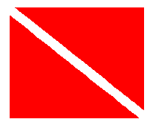
Divers’ Flag indicates that scuba divers or snorkelers are operating in the area. Stay well clear of this flag. Many states have specific distance-away requirements from 100 to 300 feet. Check your state regulations.
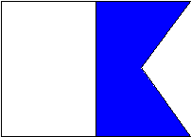
Rigid Alpha Flag is flown by a vessel engaged in diving operations. This flag does not substitute for the diver-down flag above in states that require the diver-down flag. You will usually see both flags in use. The alpha flag indicates that the vessel is restricted in ability to maneuver, in this case due to the nature of its work.

Sound Signals
Every vessel is required to carry some kind of efficient sound producing device to signal there intentions as outlined below.
Vessels are required to sound signals any time that they are in close quarters and risk of collision exists.
The term “short blast” means a blast of about one second.
The term “prolonged blast” means a blast of from four to six sconds.
The following signals are the only ones to be used to signal a vessel's intentions ( inland rules only).
One short blast - I intend to change course to starboard.
Two short blasts - I intend to change course to port.
Three short blasts - I am operating astern propulsion (backing up).
Five or more short and rapid blasts - Danger or doubt signal (I don’t understand your intent).
Note: Inland rules use sound signals to indicate intent to maneuver and a response should be received. In international rules the signals are given when the maneuver is being executed.
Vessels indicate their intention to maneuver by using sound signals. If you do not agree with or understand clearly what the other vessel's intentions are you should sound the danger or doubt signal (5 short, rapid blasts). Each vessel should then slow or stop until signals for safe passing are sounded, understood and agreed to.
The danger or doubt signal can also be used to tell another vessel that its action is dangerous. If a boat is backing up into an obstruction you would sound the danger signal to warn the operator.
Aids to Navigation — Road Signs of the Waterway
Lateral System (As Seen Entering From Seaward)
Port Side Odd Numbered Aids
 | Green Llight Only
 | Flashing (2)
 | Flashing
 | Occulting
 | Quick Flashing
 | ISO
 |   Light | 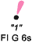 |   Lighted Buoy | 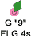
 |   Can |  |   Daybeacon
Preferred Channel No Numbers-May Be Lettered
Preferred
Channel To
Starboard
Topmost Band
Green
 |  | Green Light Only
Composite Group Flashing (2+1)
 |  |  | 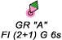
 |   Daybeacon |  |   Can
Preferred Channel No Numbers-May Be Lettered
Preferred
Channel To
Port
Topmost Band
Red
 |  | Red Light Only
Composite Group Flashing (2+1)
 |  | 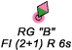 | 
 | 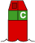  Nun |  |   Daybeacon
Starboard Side Even Numbered Aids
 | Red Light Only
 | Flashing (2)
 | Flashing
 | Occulting
 | Quick Flashing
 | ISO
 |   Light | "2"  FIR 6s |   Lighted Buoy | 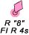
 | 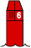  Nun | R  N"6" | 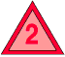  Daybeacon | 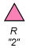
Aids to Navigation — Road Signs of the Waterway
Non-Lateral Aids to Navigation
Dayboards — May Be Lettered
White Light Only
RW  Bn | 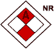 | GW  Bn |  | BW  Bn | 
The sole purpose of these diamond shaped dayboards is to help the vessel operator determine his/her location. They are like the "X's" on shopping mall maps "You Are Here." Appropriate nautical chart must be consulted to determine location.

Safe Water
No Numbers — May Be Lettered
White Light Only Morse Code
Mo(A)
 | RW N"  Mo(A) |  | RW  "A" |   Can |  |  | RW "N"
These aids are used to mark fairways, mid-channels, and offshore approach points, and have unobstructed water on all sides. They can also be used by the vessel operator transiting offshore waters to identify the proximity of intended landfall. Lighted/unlighted buoy may show a red topmark.

Isolated Danger
No Numbers — May Be Lettered
White Light Only
FI(2) 5s
 |  | BR"A"  FI(2) 5s | Lighted |  | Unlighted | BR "C"
These aids indicate an isolated danger which may be passed on all sides. They are erected on or moored on or near dangers, they should not be approached closely without special caution.

Range Dayboards — May Be Lettered
KGW | KWG | KWB | KBW | KWR | KRW | KRB | KBR | KGB | KBG | KGR | KRG
Ranges are a PAIR of aids to navigation. When the dayboards and/or lights appear to be in line with each other (Figure "A"), it assists the vessel operator in maintaining a safe course within the navigable channel. The appropriate nautical chart must be consulted when using ranges to determine whether the range marks the centerline of the navigable channel and also what section of the range may be safety traversed. Ranges are generally, but not always, lighted, and display rectangular dayboards of various colors. Ranges which are lit 24 hours a day may not have dayboards. |  |  |  |  |  |  |  |  |  | 

Typical Information and Regulatory Marks
When lighted, may display any light
rhythm except quick flashing
and flashing (2)
NW White Light Only
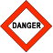 |   Exclusion  Area |   Restricted  Operations | Danger

Information and Regulatory Marks are used to alert vessel operators to various warnings or regulatory matters. Examples:
Boat Exclusion  Area  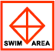 | Danger   | Controlled  Area  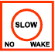
Explanation may be placed outside the crossed diamond shape, such as dam, rapids, swim area, ect.. | The nature of danger may be indicated inside the diamond shape, such as rock, wreck, shoal, dam,ect. | Type of control is indicated in the circle, such as slow, no wake, anchoring, ect.
Information  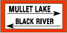 |  | 
For displaying information such as directions, distances, locations, ect. | Buoy used to display regulatory markers | May show white light  may be lettered

Intracoastal Waterway (ICW) Marks
The ICW runs parallel to the Atlantic and gulf coasts from Manasquan Inlet, New Jersey to the Mexican border. Aids to navigation marking the ICW display unique yellow symbols to distinguish them from aids marking other waters. Yellow triangles [] indicate aids should be passed by keeping them on the starboard (right) side of the vessel. Yellow squares [] indicate aids should be passed by keeping them on the port (left) side of the vessel. A yellow horizontal [] band provides no lateral information, but simply identifies aids to navigation as marking the ICW.
Note: When following the ICW from New Jersey thru Texas, keep yellow triangles [] on your starboard, yellow squares [] on your port, regardless of the color navigation aid they appear on. Examples:
 |  |  |  |  |  |  | 
Mooring Buoy
May Show White or Reflector Light
Mooring Buoys are white with a blue horizontal band. This distinctive color scheme is used to facilitate identification and to avoid confusion with aids to navigation.

Special Marks — May Be Lettered
Yellow Light Only
 |  |  | Fixed
 |  |  | Flashing
 |  |  |  |  |  | 
Unlighted |  |  |  |  |  | Lighted
These aids are not intended to assist in navigation, but rather to alert the vessel operator to a special feature or area (anchoring, traffic separation, fish net area, cable or pipeline, military exercise areas, jetties, ect.)
Inland (State) Waters Obstruction Mark
May Show White
Reflector Or Quick Flashing White Light

State Water Obstruction Mark is a black/white vertically striped buoy used to indicate to a vessel operator that an obstruction to navigation extends from the nearest shore to the buoy. This means "do not pass between the buoy and the shore." This aid is replacing Cardinal System (buoys) within the USWMS.

DURING THE DAY:
vessels at anchor must display, forward where it can be best seen, a black ball shape. (
vessels under sail also being propelled by machinery, must exhibit forward, where best seen, a black conical shape with the apex pointing down.

