Learn the phonetic alphabet. Learn to communicate correctly using the VHF radio, and one of the following of your choice: Morse Code, semaphore, international code flags. Be sure to learn and practice proper procedures for whatever method of communication you choose. Learn and demonstrate the use of the International Code in all areas of communication.

Crewmember must know the procedure to start a message, send a message, reply to a message and conclude communications.
See attached visual aids

  .  | 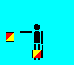   . . .
   .  . | 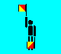   . .
  . | 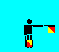  . .  .
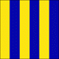    . | 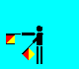  . . . .
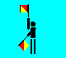  . . | 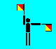  .   
   .  |   .  . .
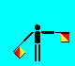    | 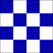   .
     | 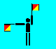  .   .
    .  | 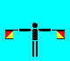  .  .
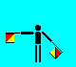  . . . |   ◆
  . .  |   . . . 
  .    |    . . 
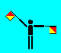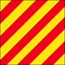   .   | 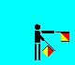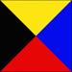    . .
  . . . . . . . . | 
 | 
  .     |   . .    
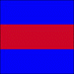  . . .   |   . . . . 
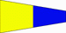  . . . . . |    . . . .
    . . . |      . .
      . |       
 | 
 | 

B-Bravo

I am taking in, discharging,
or carrying dangerous cargo
A-Alpha
I have a diver down;
keep well clear at slow speed.
D-Delta  I am maneuvering with difficulty; keep clear. | C-Charlie  "Yes" or "  affirmative
F-Foxtrot  I am disabled;  communicate with me. | E-Echo  I am directing my course to starboard.
H-Hotel  I have a pilot on board. | G-Golf  I require a pilot.
J-Juliet  I am on fire and have dangerous cargo; keep clear. | I-India  Coming alongside.  I am directing my course to port.
 | K-Kilo  I wish to communicate with you.
  L-Lima
  You should stop your vessel immediately.
N-November  “NO” or  Negative | M-Mike  My vessel is stopped; making no way.
P-Papa  All personnel return to ship | O-Oscar  Man overboard.
R-Romeo  Preparing to replenish  (At sea).  Ready duty ship (Inport). | Q-Quebec  Boat recall;  all boats return to ship.  Ship meets health regs; request clearance into port.
T-Tango  “NO” or  Negative | S-Sierra  Conducting flag hoist drill.  Moving astern.
V-Victor  I require assistance. | U-Uniform  You are running into danger.
X-X ray  Stop carrying out your intentions and watch for my signals. | W-Whiskey  I require medical assistance.
Z-Zulu  I require a tug. | Y-Yankee  Ship has visual communications duty.  I am dragging anchor.
Code/Answer  Message is understood. Also, numeric decimal point. | Error
Annul  Erase last group of letters sent. | Numerals will be sent next
TWO | ONE
FOUR | THREE
SIX | FIVE
EIGHT | SEVEN
ZERO | NINE
Second Substitute  Absence of chief of staff  Substitute for the second flag in this hoist | First Substitute  Absence of flag officer or unit commander  Substitute for the first flag in this hoist.
Fourth Substitute  Absence of civil or military official whose flag is flying on this ship.  Substitute for the fourth flag in this hoist. | Third Substitute  Absence of commanding officer  Substitute for the third flag in this hoist.

