Pyrotechnic Visual Distress Signals
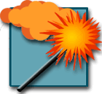  Orange Smoke:  Day Signal | 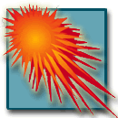  Red Meteor:  Day and Night Signal | 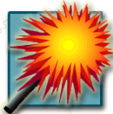  Red Flare:  Day and Night Signal

Non-Pyrotechnic Visual Distress Signals
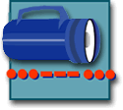  Electric Light:  Night Signal |   Orange Flag:  Day Signal | 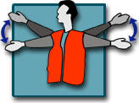  Arm Signal:  Although not a U.S. Coast Guard approved VDS, use this arm action to indicate you need help if you do not have other visual distress signals available.

VDS Use on State and Federally Controlled Waters
Vessels must observe state requirements and carry VDSs when operating on waters under state and federal control. These include waters along the coast; the territorial seas; and waters that are two miles wide or wider and are directly connected to one of the above. The state requirements are the same as the U.S. Coast Guard requirements.
Use good judgment when navigating on open waters and make sure you have the ability to signal for help if needed. State requirements for VDSs do not apply on large, open waters inland from the coast that are not under federal control, but they are strongly recommended!

