Midshipmite: Marlinespike Seamanship: About Rope

A. Terminology:

Standing end: the longer part of a line which is fixed during the tying of a knot

Working end: the end of the line which is used or tying or is being used.

Bitter end: the free end of a line

Lay: To place together (strands) to be twisted into rope; the direction that the rope is put together.

Bight: The part of the rope between the end and the standing part. A loop formed by folding the rope back on itself

Strand: A complex of fibers or filaments that have been twisted together to form a rope.

Fibers: fibers make up the individual strands of a rope

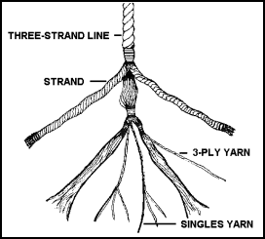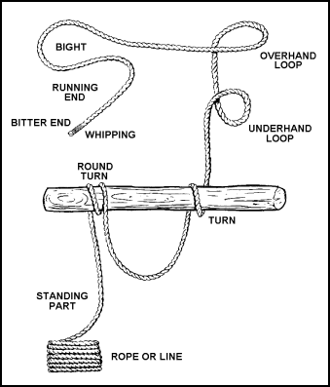
B. Types of Rope:

- Polypropylene

  - Make: light weight synthetic material
  - Use: Because of its light weight, polypropylene is the only rope which floats. For this reason, it is very popular for pool markers and water sports.
  - Care: Poly is affected by sunlight deterioration, more so than any other synthetic or natural fiber rope, but its life can be extended by storing it away from direct sunlight.
  - Other: Poly begins to weaken and melt at 150°F, the lowest melting point of all synthetic ropes. It is not as strong as nylon or polyester, but 2-3 times stronger than manila. Because poly is less expensive than other fibers, it is the most popular all-purpose rope for the average consumer. Hollow braided poly can be spliced.

- Nylon

  - Make: Nylon
  - Use: Nylon is the strongest of all ropes in common use. When stretched it has a "memory" for returning to its original length. For this reason it is best for absorbing shock loads, as is the case when lifting or towing
  - Care: Nylon lasts 4-5 times longer than natural fibers because it has good abrasion resistance and is not damaged by oil or most chemicals. Like manila, nylon has good resistance to ultraviolet deterioration from sunlight, referred to as "U.V. stability".
  - Other: nylon is one of the types of lines used for docking on the Tradewind.

- Polyester

  - Make: polyester
  - Use: Polyester is very close to nylon in strength when a steady force is applied. However, unlike nylon, polyester stretches very little and therefore cannot absorb shock loads as well.
  - Care: It is as equally resistant as nylon to moisture and chemicals, but is superior in resistance to abrasion and sunlight.
  - Other: Polyester is the most popular general purpose rope in the boating industry.

    - Manila

      - Make: A hard natural fiber
      - Use: It is very popular for public utility construction and repair because it will not melt on contact with hot wires or equipment like synthetics do. It will burn, however, if the temperature is very high or if the rope is in contact with the wires/equipment for an extended period of time. Manila holds knots firmly and stretches very little.
      - Care: manila is especially resistant to sunlight
      - Other: It must be stored dry to avoid mildew. Chemicals will cause it to deteriorate.

