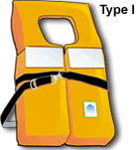 | TYPE I: Offshore Life Jacket  These vests are geared for rough or remote waters where rescue may take awhile. They are excellent for flotation and will turn most unconscious persons face up in the water.
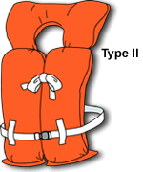 | TYPE II: Near-Shore Vest  These vests are good for calm waters and fast rescues. Type II vests may lack the capacity to turn unconscious wearers face up.
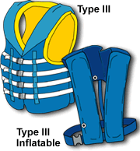 | TYPE III: Flotation Aid  These vests or full-sleeved jackets are good for calm waters and fast rescues. They are not for rough waters since they will not turn a person face up. This type of life jacket (personal flotation device, or PFD) is generally used for water sports.
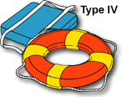 | TYPE IV: Throwable Device  These cushions or ring buoys are designed to be thrown to someone in trouble. They are not for long hours in rough waters, non-swimmers or the unconscious.
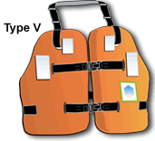 | TYPE V: Special Use Device  These windsurfing vests, deck suits, hybrid life jackets and others are designed for specific activities, such as kayaking or water skiing, and usually must be worn to be accessible. These windsurfing vests, deck suits, hybrid life jackets and others are designed for specific activities, such as kayaking or water-skiing, and usually must be worn to be accessible. To be acceptable, Type V life jackets must be used in accordance with their label.

Personal Flotation Devices (PFDs)
- All vessels (including canoes and kayaks) must have at least one USCG–approved Type I, II or III life jacket (PFD) for each person on board.
- One Type IV (throwable) USCG–approved PFD must be on board vessels 16 feet or longer, in addition to the requirement above. Canoes and kayaks are exempt from this requirement.
- Children 12 years old and younger must wear a USCG–approved life jacket at all times when underway in a vessel less than 19 feet in length, unless in a fully enclosed area.
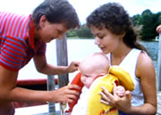
- Each person on board a personal watercraft (PWC) and anyone being towed behind a vessel must wear a Type I, II or III USCG–approved life jacket. Inflatable life jackets are not recommended for these activities.
- A Type V life jacket may be substituted for any other type if it is specifically approved by the USCG for the activity at hand and is being worn.
- All life jackets (PFDs) must be:
  - U.S. Coast Guard–approved, which means clearly marked with the USCG approval number
  - In good and serviceable condition
  - Readily accessible, which means you are able to put the life jacket on quickly in an emergency
  - Of the proper size for the intended wearer; sizing for life jackets is based on body weight and chest size.

