Knots and Mooring Hitches

Know simple knots and mooring hitches. Be able to tie with ease and explain the seaman's common usage of the square knot, bowline, clove hitch, round turn and two half hitches, sheet bend, cleat hitch, and figure eight knot.

Knots

Round turn and Two Half Hitches
Use: For tying up when the line is already under tension.

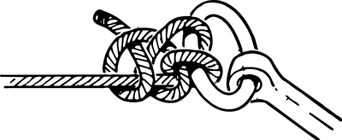

Square Knot
Use: For tying together two ends of the same diameter.
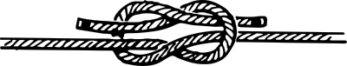

Sheet Bend
Use: For tying together two ends of different diameter.
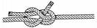

Bowline
Use: Makes a loop in the line which will not slip. Also known as the “king of all knots”. We typically use this knot on our boat for docking purposes.
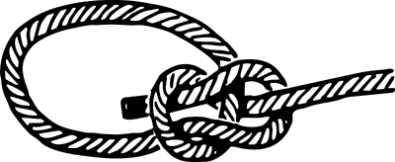

Figure Eight
Use: A stop knot which can be used to keep a line from coming out of a block.
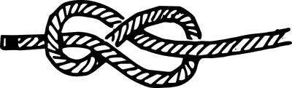

Clove Hitch
Use: For tying a line to a post; can work loose if it is slacked and loaded.
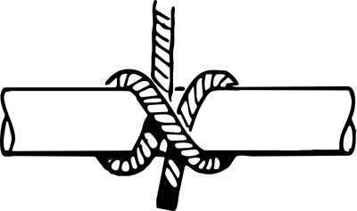
Cleat Hitch
Use: to attach a line to a cleat. It is often used to secure a boat to a dock.
