Whipping
Rope ends, if left unbound, tend to unravel. To prevent this we bind or ``whip'' the ends with a fine, waxed yarn or twine before the rope is used. There are several methods for whipping rope ends; the easiest and least durable is called Ordinary Whipping; slightly more difficult, but more permanent, is Needle Whipping. Modern lines of synthetic material can be melted with a match or soldering iron causing the fibers to fuse together to form a temporary fastening.

Ordinary Whipping (Figure 12)
An ordinary whipping is made by placing the end of the yarn at the end of the rope and laying a loop along the rope (the beginning of your whipping should start approximately the length of the diameter below the end of the rope. The length of your whipping should also be approximately the diameter of the line you are using). The yarn is then tightly wound around both loop and rope, binding them together. Wind to a length roughly equal to two diameters of the rope you are whipping.
The whipping is finished by putting the winding end B through the loop, then pulling end A tight until the loop is drawn back out of sight. Both A and B should be trimmed flush with the whipping and the rope then cut to length.
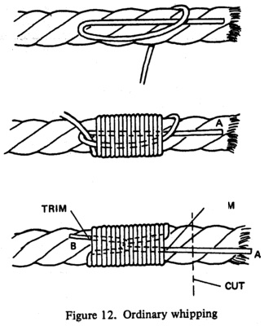

Sewn or Needle Whipping (Figure 13)
The sewn or needle whipping is the best method of assuring your line or rope stays tightly wrapped and strong. Make a knot in the end of a section of twine that you have threaded through a sail needle. Tuck the whipping twine under a strand and pull the knot up inside the rope so there will be no bump under the wraps. Make your wrappings toward the end of the line until you have enough wraps to equal one diameter of the rope you are whipping (again when you are finished, your whipping should be approximately the length of the diameter below the end of the rope). Bring the needle under a strand and bring your whipping twine back over your wrapping following the valley or twist in the rope, and tuck the needle under a strand on the inside edge of the wrappings. Continue this process until all valleys (3) are covered. Your twine should now be back on the inside end of your wrapping. To finish your whipping, sew the needle back through the interior of the line making a number of insertions until the twine is 3"-4" in from your wrappings. Trim the twine close to the line and trim the line below the whip for a neat job. When done properly it should be difficult to see where the whipping starts or finishes.
The whipping is often done with a doubled whipping twine to speed the process.
