Mariner Scout Ship TRADEWIND History

The Tradewind began as a Cadette troop in Menlo Park, CA in 1964. By 1956, the girls and their leaders decided to become a Mariner Scout Ship. They picked the name TRADEWIND, because the girls liked the sound of it!

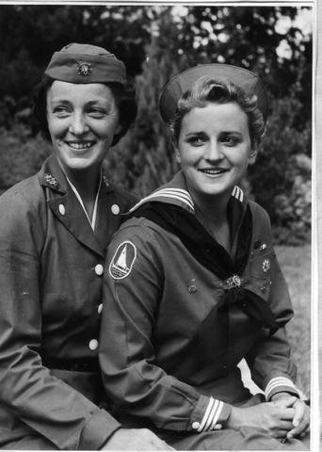
The first skipper of the Tradewind was Mrs. Jackie Harker. Her daughter Jill was a crew member. There have been several skippers over the years, including Mrs. Betty Aiken, Miss Sue Brenner, Mr. Umbert von Hofen, Mrs. Sally von Hofen, Ms. Patty von Hofen, Mrs. Patricia Knighton, and finally, Mrs. Teri Marzano.

The Tradewind participated in GAMs, which were nautical competitions held for all the Mariner Scouts in the area, as well as local Girl Scout activities and social events hosted by the Sea Scouts. They even hosted a party for the Italian Navy Cadets in 1957! GAM’s were discontinued in Northern California in the 1990’s, since there were only two troops left, Tradewind and Odyssey. From
Mrs. Harker & daughter Jill, 1957
that point on, the Tradewind has participated in the Sea Scout regattas, in the
spring.

Over the years, the Tradewind has participated in a great variety of community service, at first with the Peninsula Children’s Center, and then at different times at the Fitzgerald Marine Reserve in Half Moon Bay, the Redwood City Public Library children’s programs, the Redwood City Education Foundation, and many, many Coastal Clean Up Days, not to mention the many, many flag ceremonies for various community organizations!

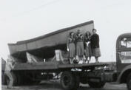
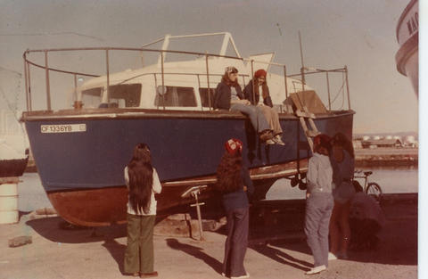
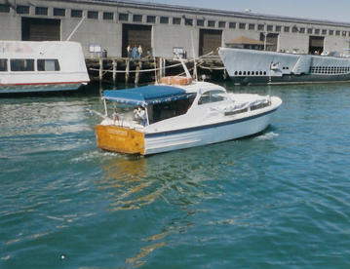
There have been many boats over the years. The crew has always participated fully in the maintenance and operation of each and every boat. The current boat accommodates 12 crew members and 4 officers in separate quarters. It is the most comfortable boat the troop has ever had!
28’ Personnel Launch, 1973
Tradewind’s first boat, 1957
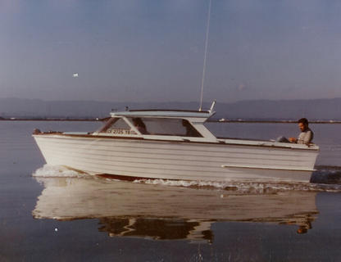
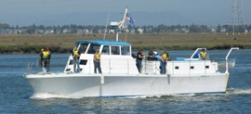
23’ Chris Craft, 1981
35’ Chris Craft, 1983
Current Vessel, 52’ Landing Craft, Swimmer Reconnaisance (LCSR) acquired in 1993 from
South San Francisco Sea Scouts

