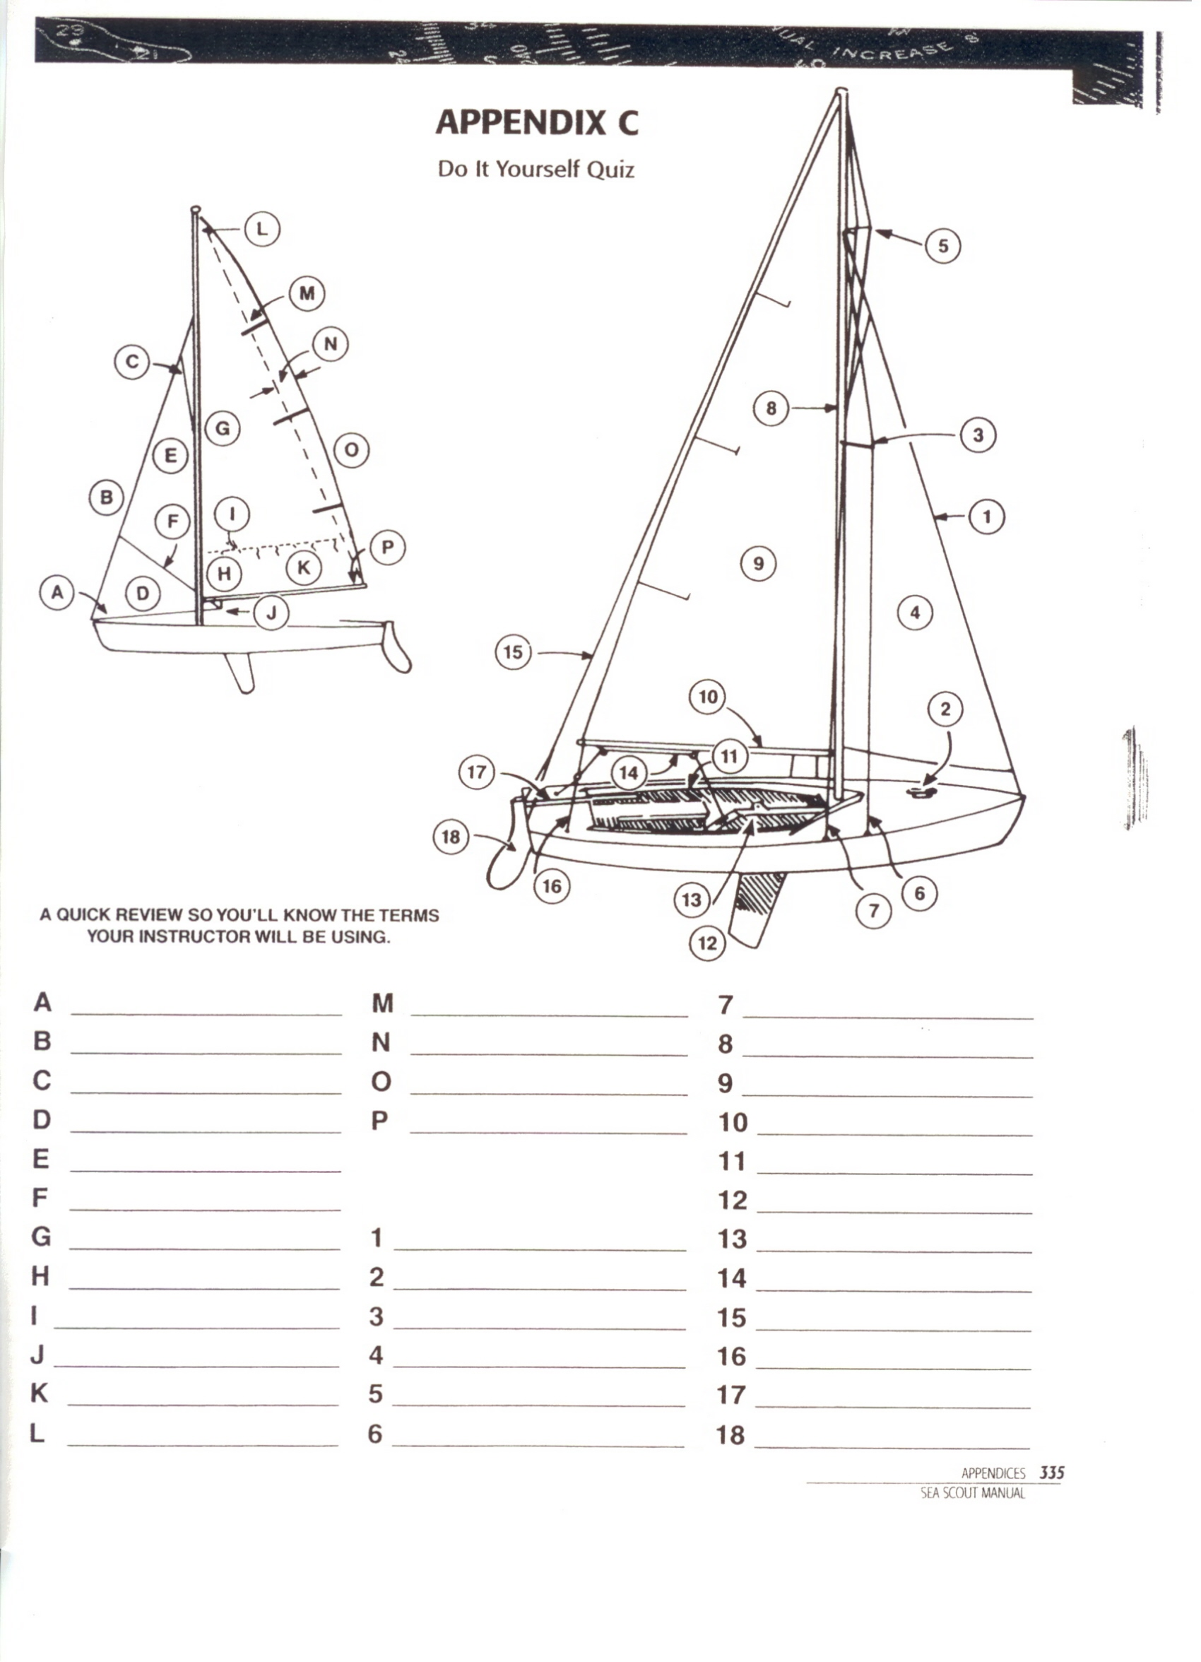
Tack
Luff
Head
Foot
Jib
Miter Seam
Luff
Clew
Reef Points
Clew
Leach
Roach
Batten
Tack
Foot
Head
Boom
Coaming
Centerboard
Centerboard Trunk
Jib Stay
Main Sheet
Cleat
Spreader
Jib
Jumper Strut
Upper Shroud
Aft Stay/Back Stay
Traveler
Tiller
Rudder
Lower Shroud
Mast
Main Sail

