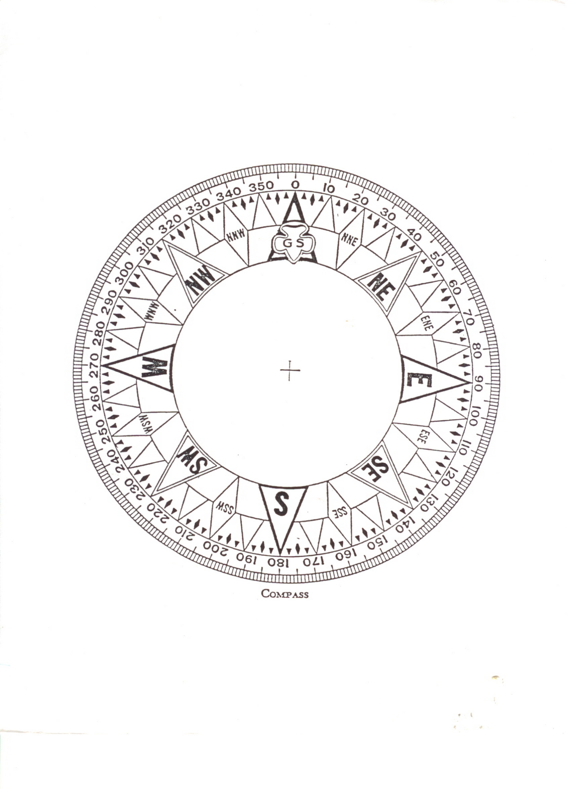
Score: ____________________________

Crewmember:_____________________

Date: ____________________________


